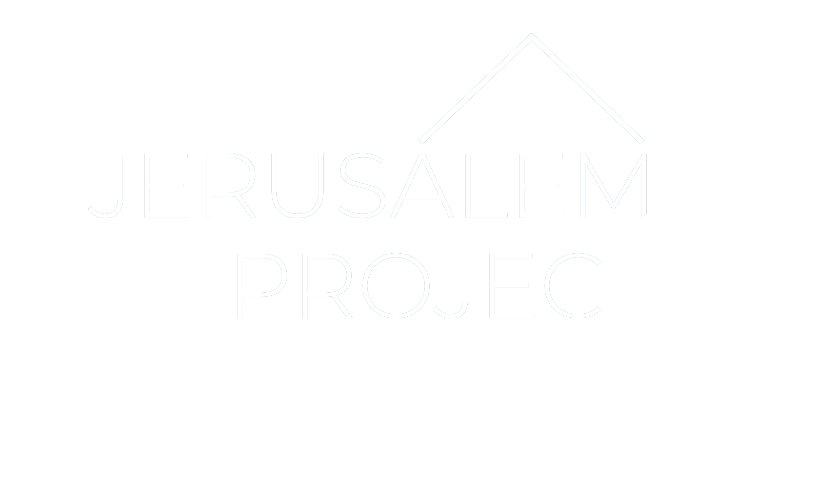
GROUP LEADERS:
TURN IN ORIGINAL &
MAKE A COPY FOR
YOUR RECORDS

PARTICIPANT FORM
PLEASE PRINT LEGIBLY

Note: All Jerusalem Project participants must complete this form. Participants under age 18 must have the signature of a parent or guardian to be eligible to participate in Jerusalem Project. This form includes a Medical Release and Model Release. All Sections Must Be Completed For Eligibility. Social Security number below is optional and will only be used to expedite treatment in an emergency. Return this form to your Group Leader as soon as possible. Group leaders are responsible for submitting this entire form to Jerusalem Project.
Participant Information

Name: (Last) (First) Date of Birth / / Age Sex Grade Completed: Home Address: City: State: Zip: Home Phone: Work Phone:
Church Name: Church City: Shirt Size:
In Case of Emergency, contact (must be a family member—list 2):
Name: Cell #: Day #: Night #: Name: Cell #: Day #: Night #:

Project Information
Project Location (County): Project Date (Month/Year):

Medical Profile

Generally, my health is: (Check One) □ Excellent □ Good □ Fair □ Poor
If Fair or Poor, please explain your condition: List any medical difficulties for which you are CURRENTLY being treated: List any medication you are CURRENTLY taking: List any medicines or substance to which you are Allergic: Family Physician: _ Date of Tetanus Immunization / /
Insurance Company: Policy or Group #:
(Attach copy of insurance card)
Address (City, State, Zip): Subscriber Name: Subscriber Number: Place of Employment: Subscriber Occupation: Work Phone:

Authorization for Medical Treatment
For myself and for and on behalf of my participant child under 18 years of age (“Participant”), I hereby give my permission for any physician, hospital, or health care facility to provide medical care, treatments, and administer medications to Participant as deemed necessary by a physician and our Jerusalem Project Group Leader during the Jerusalem Project.

Release of All Claims
For and in consideration of participation in the Jerusalem Project, for myself and Participant I hereby acknowledge that we understand that risks, including Inherently dangerous risks, are associated with the Jerusalem Project (“Risks”), and we hereby assume all such Risks and for myself and Participant. I hereby release the Jerusalem Project, and all of its agents, employees, Officers and Directors, including Jerusalem Project board, and their respective licensees, successors and assigns, from any and all Risks, actions, causes of action, claims, demands, liabilities and obligations of any and every nature whatsoever, including, without limitation, for illness, personal injury, death, property damage, and personal or proprietary rights to my and Participant’s image(s) (collectively herein, “Claims”), and hereby hold Jerusalem Project harmless and agree to fully indemnify Jerusalem Project from and against any and all Claims.
I hereby personally assume full responsibility for any and all Claims and for any and all hospital and medical bills for myself and Participant. I hereby certify to Jerusalem Project that I have obtained and will maintain in full force and effect during the Jerusalem Project adequate primary medical insurance for myself and Participant. I understand that only limited or no supplemental medical insurance may be provided for Jerusalem Project participants, to which Limitations and exclusions apply. In the event it is necessary for me or Participant to return home due to disciplinary action, for medical reasons, or otherwise, I hereby personally assume full responsibility for all such transportation arrangements and costs.

Consent to Use and Publication of Image
For and in consideration of participation in the Jerusalem Project, for myself and Participant, I hereby give Jerusalem Project the absolute, unconditional, and irrevocable right and permission to use my name and Participant’s name and to use, reproduce, edit exhibit, project, display, copyright, and publish, photo- graphic images and/or moving pictures and/or videotaped images of me and/or Participant, with or without voice, in which I and/or Participant are included, in whole or in part, photographed, taped, videotaped, and/or recorded prior to, during, and/or after the Jerusalem Project, and to circulate same in any and all forms and media for art, advertising, trade purposes, and competition, of every description and any other lawful purpose whatsoever, and I hereby consent to the use of all printed matter in conjunction therewith and waive all rights to inspect and/or approve drafts, finished products, and/or editorial, promotional, and printed copy, and sound tracks that may be used in connection therewith, and waive all rights to control any aspect of any production, alteration, use, distribu- tion, or disposition of said products, copy, and/or sound tracks, and hereby discharge and agree to hold Jerusalem Project harmless and fully indemnify Jeru- salem Project from and against any and all Claims arising by virtue of any production, alteration, use, distribution, or disposing thereof, and from and against all Claims arising by virtue of any blurring, distortion, alteration, optical illusion, or use in composite form, whether intentional or otherwise, that may occur or be produced in the production, processing, duplication, projecting, or displaying of said images of me and/or Participant, and from any and all Claims for violation of any personal and all proprietary rights of that of I or Participant may have or may claim to have in connection with such images and with the production, alteration, use, distribution, and disposition thereof.

--Please complete and sign below (youth under 18 years of age requires parent/guardian signature)--

Participant’s Signature: Date: / /

Parent/Guardian’s Signature: Relation: Date: / /

